Tonight's Cast

Emcees Amy & Leif
Trixie Amy
Frank N. Furter Diego
Brad Majors Jesus
Janet Weiss Sammie
Riff Raff Steffan
Magenta Terry
Columbia Mandi
Dr. Scott Tim
Eddie Tracy
Rocky Eddie Pie
Crim Leif
Phantom Paco

Transylvanians

Cheryl Poncho Andrew Peter
Jordan Carlos Kayla

Midnight Mafioso

Stage Director: Brandon Stage Director: Mandi Technical Director: Zac Inventory: Aleah
Tranny Coordinator: Cheryl Webmaster: Bill
Sound: Tracy & Leif Secretary: Aleah
Accountant: Kim Juu Photographers: Liz
Props Foxes: Jo & Shevaun House Manager: Tracy & Drew
Security: Mark, Kay Kay, Jasmine, Fluffy, Data
Merchandise: Jenna, Dakota, Courtney
Spotlights: Kim, Lara, Christina, Nikkie, Kate
Scenic Tech: Zac, Mit, E van, Eddie, Paco

Denton Times

www.midnightinsanity.org
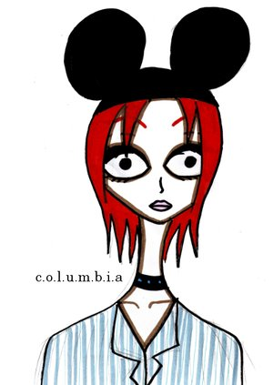

Hoopla, Denton!! Welcome to the theme night that you NEVER thought would actually happen...Disney Night!!! That's right, all of our performers will be putting a perverted spin on all of the childhood characters that you know and love...so be ready for a mind fuck. And remember, we're here every Saturday night just for *you*, so come on back and see us any old time.

Make sure not to miss March Lingerie Night, coming up on the 26th!!! Bonus points if you show up in Saint Patty's Day attire. And if you're 18 years of age or older, be sure to come with a valid ID so you can play in our Lingerie Contest, win awesome prizes, and maybe end up with a groupie of your own...

Coming up on April 2nd, we have our annual April Fools' Show. If you've been here in years past, you've seen the CRAZY ASS SHIT we attempt for this extra special show, and we're planning on pulling out all the stops this year as well. So be here to check out true Midnight Insanity!!

Like what you see? Want to join the eleganza that IS Midnight Insanity? Well lucky for you, we're always looking for some unsuspecting, innocent young thangs to corrupt. You don't get paid, but you get invited to our kick ass parties, meet some really awesome people, and channel your creativity into something besides your weekly-underwater-basket-weaving-class. So talk to Brandon or Mandi about what you need to do to join our little family...er cult...er cast. Yes, join our happy, harmonious, harmless little cast.
'
Have some suggestions for the show? A theme night you'd like to see? A virgin sacrifice you'd like to watch? Adoring fan mail for our oh so sexy cast members? E-mail us! It's easy, just send your message to: <cast member's first name>@midnightinsanity.org. For example, to tell our sparkly disco ball how much you love her tap dance, just email mandi@midnightinsanity.org!

Brandon's Nonsensical Ramblings:
"And don't fuck it up."

